CHAPTER 17
FINANCE AND CORPORATE STRATEGY

Objectives
To show how to use finance theory to analyze strategic decisions such as:
- Acquiring or merging with another firm
- Spinning off a business unit as a separate firm
- Investing in real options

Outline
17.1 Mergers and Acquisitions
17.2 Spinoffs
17.3 Investing in Real Options

Summary
- There are three valid reasons for a merger or acquisition:
- To reduce operating costs through synergies
- To reduce taxes
- To take advantage of bargains in the stock market
- Diversification of risk is a poor reason for two firms to merge, because in general shareholders can diversify their portfolios on their own; they do not need the firm to do it for them.
- An extremely important feature of investment projects is the ability of managers to delay the start of a project, or once started, to expand it or to abandon it. Failure to take account of these management options will cause an analyst evaluating the project to underestimate its NPV.
- Recognizing the similarity between financial options and real managerial options is important for three reasons:
- It helps in structuring the analysis of the investment project as a sequence of managerial decisions over time,
- It clarifies the role of uncertainty in evaluating projects,
- It gives us a method for estimating the option value of projects by applying the quantitative models developed for valuing call options on stocks.
Solutions to Problems at End of Chapter

- Hampshire-Cathaway (H-C), a large established corporation with no growth in its real earnings, is considering acquiring 100% of the shares of Trilennium Corporation, a young firm with a high growth rate of earnings. The acquisitions analysis group at H-C has produced the following table of relevant data:

 | Hampshire-Cathaway | Trilennium
Earnings per share | $3.00 | $2.00
Dividend per share | $3.00 | $.80
Number of shares | 200 million | 10 million
Stock price | $30 | $20

H-C’s analysts estimate that investors currently expect growth of about 6% per year in Trilennium’s earnings and dividends. They assume that with the improvements in management that H-C could bring to Trilennium, its growth rate would be 10% per year beginning one year from now with no additional investment outlays beyond those already expected.
- What is the expected gain from the acquisition?
- What is the NPV of the acquisition to H-C shareholders if it costs an average $30 per share to acquire all of the outstanding shares?
- Would it matter to H-C’s shareholders whether the shares of Trilennium stock are acquired by paying cash or H-C stock?

SOLUTION
- Currently the shares of Trilennium have a market value of $200 million. Since Trilennium’s expected growth rate is currently 6%, the constant growth rate DDM would imply that Trilennium’s market capitalization rate is 10.24%:
k = DIV/ P + g = ($0.80 x 1.06) / $20 + .06 = .1024
If Trilennium’s growth rate increases to 10% under H-C’s control, then its price should soar to $353 per share
P = DIV/(k-g) = (.8 x 1.06)/.0024 = $353
- NPV of the acquisition = 10 million shares x $323 per share = $3.23 billion
- It should not matter to H-C’s shareholders how the $300 million cost of acquiring Trilennium is paid.

- A film studio, Nadir Productions, has to decide whether to make a movie out of the book ”Planetary Wars,” which it has acquired the rights to. The studio’s experts estimate that the production costs for the film will be $30 million and the subsequent cash flows net of distribution costs and taxes to be received a year later are expected to be $60 million with a probability of .5 and $10 million with a probability of .5. The studio uses a discount rate of 20% in deciding whether to accept such projects.
- What is the NPV of the project? Should the project be accepted?
At this point a new MBA on the CFO‘s staff suggests that they have not taken account of the option to produce a sequel to the movie. If the movie succeeds at the box office, then surely they will want to make “Planetary Wars II” the following year.
- Draw a decision tree for the project.
- Assuming that the cost estimates and the distribution of future cash flows for the sequel are the same as for the original movie, how does taking account of the option to make a sequel affect the desirability of the project?
- Suppose that Nadir’s executives believe that a successful film of this genre can have as many as three sequels. What is the NPV of the project taking account of this?
SOLUTION
- The expected future cash flow 1 year from now is .5 x $60 million + .5 x $10 million = $35 million.
NPV of the project = -$30 million + ($35 million.)/1.2 = -$833,333. Since the NPV is negative, it should be rejected.
- Decision tree for movie project with possibility of a sequel.

- If the distribution of cash flows for the sequel are the same as for the original movie, then it will have a negative NPV just like the original movie. In this case, taking account of the opportunity to make a sequel does not affect the desirability of the project. However, if the film studio thought that the success of the original would make the success of a sequel more likely, it might cause the decision to be reversed. For example, suppose that the probability of a sequel succeeding given that the original movie succeeded is .8 instead of .5. In that case the expected 2nd year cash flow from the sequel along the upper branch of the decision tree would be $50 million instead of $35 million, and the NPV of sequel = -$30 million + ($50 million.)/1.2 = $11.67 million. And the NPV of making the original movie becomes positive.
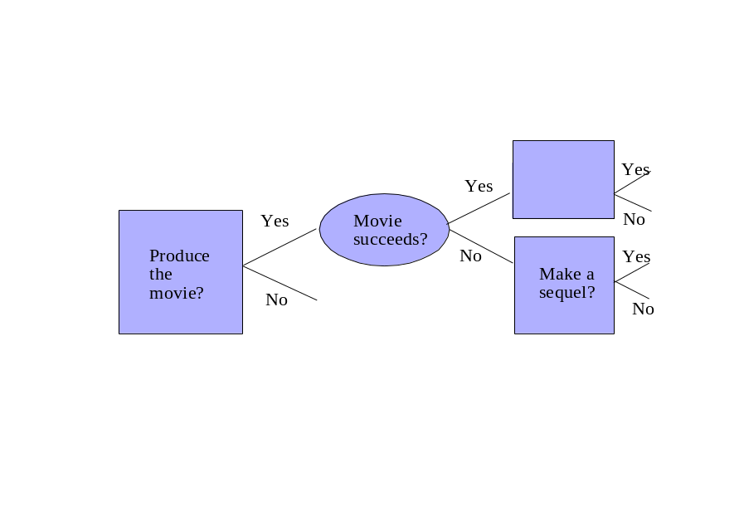
- If there is no change in the likelihood of a sequel succeeding, then the NPV of the project will not improve. However, if the probability of success goes up, given success of the preceding movie, then the NPV of the project will increase.

- Suppose Microstuff Corporation has the opportunity to invest in a new computer technology that would use television sets to connect to the internet. In the first phase an initial outlay of $100 million is required for a pilot project to determine the feasibility of the technology. In the second phase, one year from now, an additional investment of $1 billion would be required. Suppose that viewed from today’s perspective the value of the project a year from now is a random variable with a mean of $1.1 billion. The required rate of return on the project is 10% per year. The standard deviation of the continuously compounded rate of return on this project is .2. The continuously compounded riskless interest rate is 5%. Use the Black-Scholes options pricing model to help determine if this is a worthwhile investment.

SOLUTION
First we need to determine the value of the project now. We know the expected value of the project a year from now is S₁ = $1.1billion. The current value of the project will be the present value of this expected future value, discounted at the required rate of return on the project. So current value of the project S = S₁ / (1+10%) = $1 billion.

To determine the value of this option we can use the same valuation models developed in Chapter 15 to price a European call option on a stock. Applying the Black-Scholes formula:

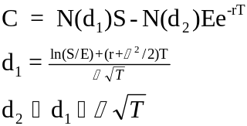

where,
C = price of the option
S = current value of the project
E = exercise price
T = time to maturity of the option in years
σ = standard deviation of the annualized continuously compounded rate of return on the project

Inputting in the numbers, we have
d₁ = (In(1/1) + (.05 + (.2)²/2)1)/.2(1) ^{.5} = 0.35
d₂ = .35 − .2(1) ^{.5} = 0.15
C=$0.104 Billion.

Since the value of the option is larger than $100 million, this is a worthwhile investment.
The NPV of investment is about 4 million.

